**Setting Up Hibernate**

Setting up a Hibernate project is easy. The project that I’ve prepared for this book is a Maven-based code developed on NetBeans IDE. I won’t be going into detail on setting up the environment, but the following steps should help you. Although I have used NetBeans for developing code, you can use any of your favorite IDEs to work on this project. Also, you can swap MySQL with any other databases, including in-memory

ones such as Derby or HyperSQL. First, you should set up the essential development environment consisting of JDK 5.0+,NetBeans IDE, Maven, and the MySQL database (you may have had this environment already!). I have used JDK 6, NetBeans 7.3, Maven 3.2, and MySQL 5.2 for developing

the code, and the Hibernate version is 4.2.3. Final. Once you have the dev environment sorted, the next step is to create a Maven project in NetBeans (or Eclipse). Add the appropriate Hibernate dependencies to the *pom.xml* file as shown here:

**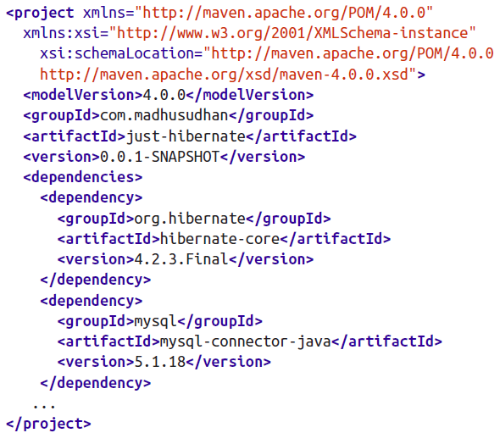**

Maven will resolve the related dependencies when building the project.

The next step is setting up your database. If you already have a database, you can skip this step. I am using MySQL database. Download the latest MySQL package and install it on your machine (you may have to go through the manual to set this up correctly).

Most of the tables in this project were autogenerated by Hibernate; that is, Hibernate would create them on the fly (if they do not exist) by reading your configuration. We need to set a property, hbm2ddl.auto, in the Hibernate configuration file (*hibernate.cfg.xml*) to the appropriate value for this autogeneration to happen, as follows:

**AcroRd32_2017-01-13_14-55-46.png**